**College Application Form**

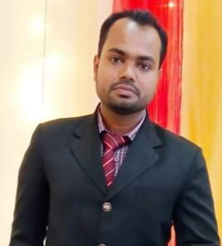

Md. Abdul Munjer

Name

Male

11nov 1993

Date of Birth Gender

Mobile No

01717513771

Munjer.ovi@gmail.com

Email

Address

522/2B, South Monipur , Mirpur , Dhaka

Mostafa Anower Kamal

Father’s Name

Profession Businessman Mobile 01718799993

Mst. Laila Momtaj

Mother’s Name

Profession Housewife Mobile 01713178614

Education

Degree B.sc

World University Of Bangladesh

University

3.25

CGPA Group Engineering

2017

Passing Year signature of student